|  |  |  |  |
| --- | --- | --- | --- |
| **Roll No: 113** | **Name:Harshita Shetty** | **Div: B** | **Batch: B2** |

**Experiment No.03:CDMA**

**AIM:** To implement a basic function of Code Division Multiple Acces (CDMA) using python.

**Theory:** Code-division multiple access (CDMA) is a channel access method used by various radio communication technologies. CDMA is an example of multiple access, where several transmitters can send information simultaneously over a single communication channel. This allows several users to share a band of frequencies (see bandwidth). To permit this without undue interference between the users, CDMA employs spread spectrum technology and a special coding scheme (where each transmitter is assigned a code). CDMA is used as the access method in many mobile phone standards. IS-95, also called "cdmaOne", and its 3G evolution

CDMA2000, are often simply referred to as "CDMA", but UMTS, the 3G standard used by GSM carriers, also uses "wideband CDMA", or W-CDMA, as well as TD-CDMA and TD-SCDMA, as its radio technologies. The intended 4G successor to CDMA2000 was UMB (Ultra Mobile Broadband); however, in November 2008, Qualcomm announced it was ending development of the technology, favouring LTE instead CDMA Orthogonality: Techniques generally used are direct sequence spread spectrum modulation (DS-CDMA), frequency hopping or mixed CDMA detection (JDCDMA). Here, a signal is generated which extends over a wide bandwidth. A code called spreading code is used to perform this action. Using a group of codes, which are orthogonal to each other, it is possible to select a signal with a given code in the presence of many other signals with different orthogonal codes. CDMA Autocorrelation: Autocorrelation of the sequence, determines the ability to synchronize and lock the spreading code for the received signal.

**Code:**

import numpy as np c1=[1,1,1,1] c2=[1,-1,1,-1] c3=[1,1,-1,-1] c4=[1,-1,-1,1] rc=[]

print("Enter the data bits :")

d1=int(input("Enter D1 :")) d2=int(input("Enter D2 :")) d3=int(input("Enter D3 :")) d4=int(input("Enter D4 :")) r1=np.multiply(c1,d1) r2=np.multiply(c2,d2) r3=np.multiply(c3,d3) r4=np.multiply(c4,d4) resultant_channel=r1+r2+r3+r4;

print("Resultant Channel",resultant_channel)

Channel=int(input("Enter the station to listen for C1=1 ,C2=2, C3=3 C4=4 : "))

if Channel==1:

rc=c1 elif Channel==2:

rc=c2 elif Channel==3:

rc=c3 elif Channel==4:

rc=c4

inner_product = np.multiply(resultant_channel,rc)

print("Inner Product",inner_product) res1=sum(inner_product)

data = res1/len(inner_product) print("Data bit that was sent",data)

**GitHub Link: https://github.com/shettyharshita/Mobile-Computing**

**OUTPUT:**

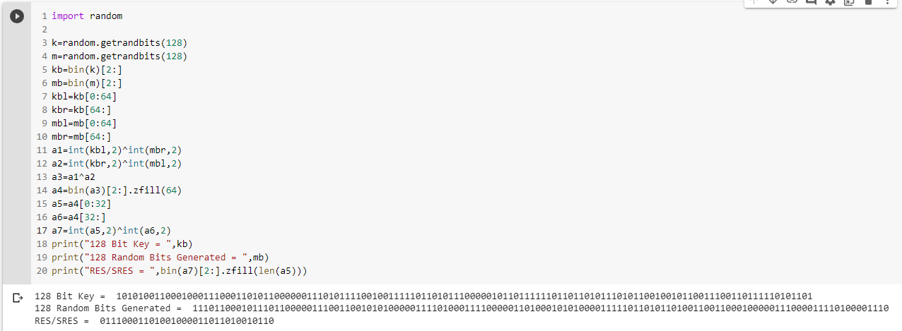

**Conclusion:** The experiment was about the CDMA which is successfully implemented and verified.